38.30: 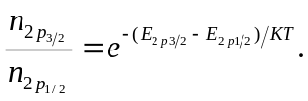
From the diagram 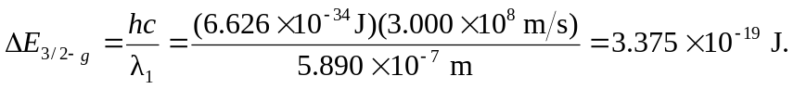
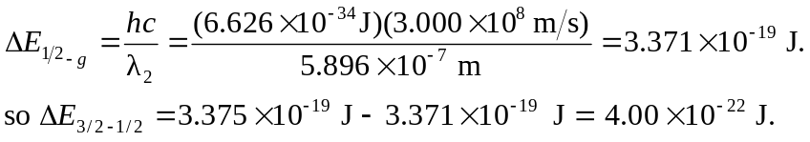
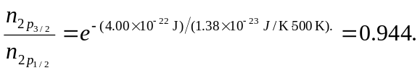 So more atoms are in the 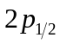 state.

